Đinh Hải Phong – Module JavaWeb – Test

Table Users(id, name, address, age, phone, image, id_position)

Table Position(id, position)

A: Requirements: Write a program to retrieve a list of users, add new users, edit users by id and delete users by id.

Complete:

* Get all user list including the following information: name, address, age, phone, image, position.

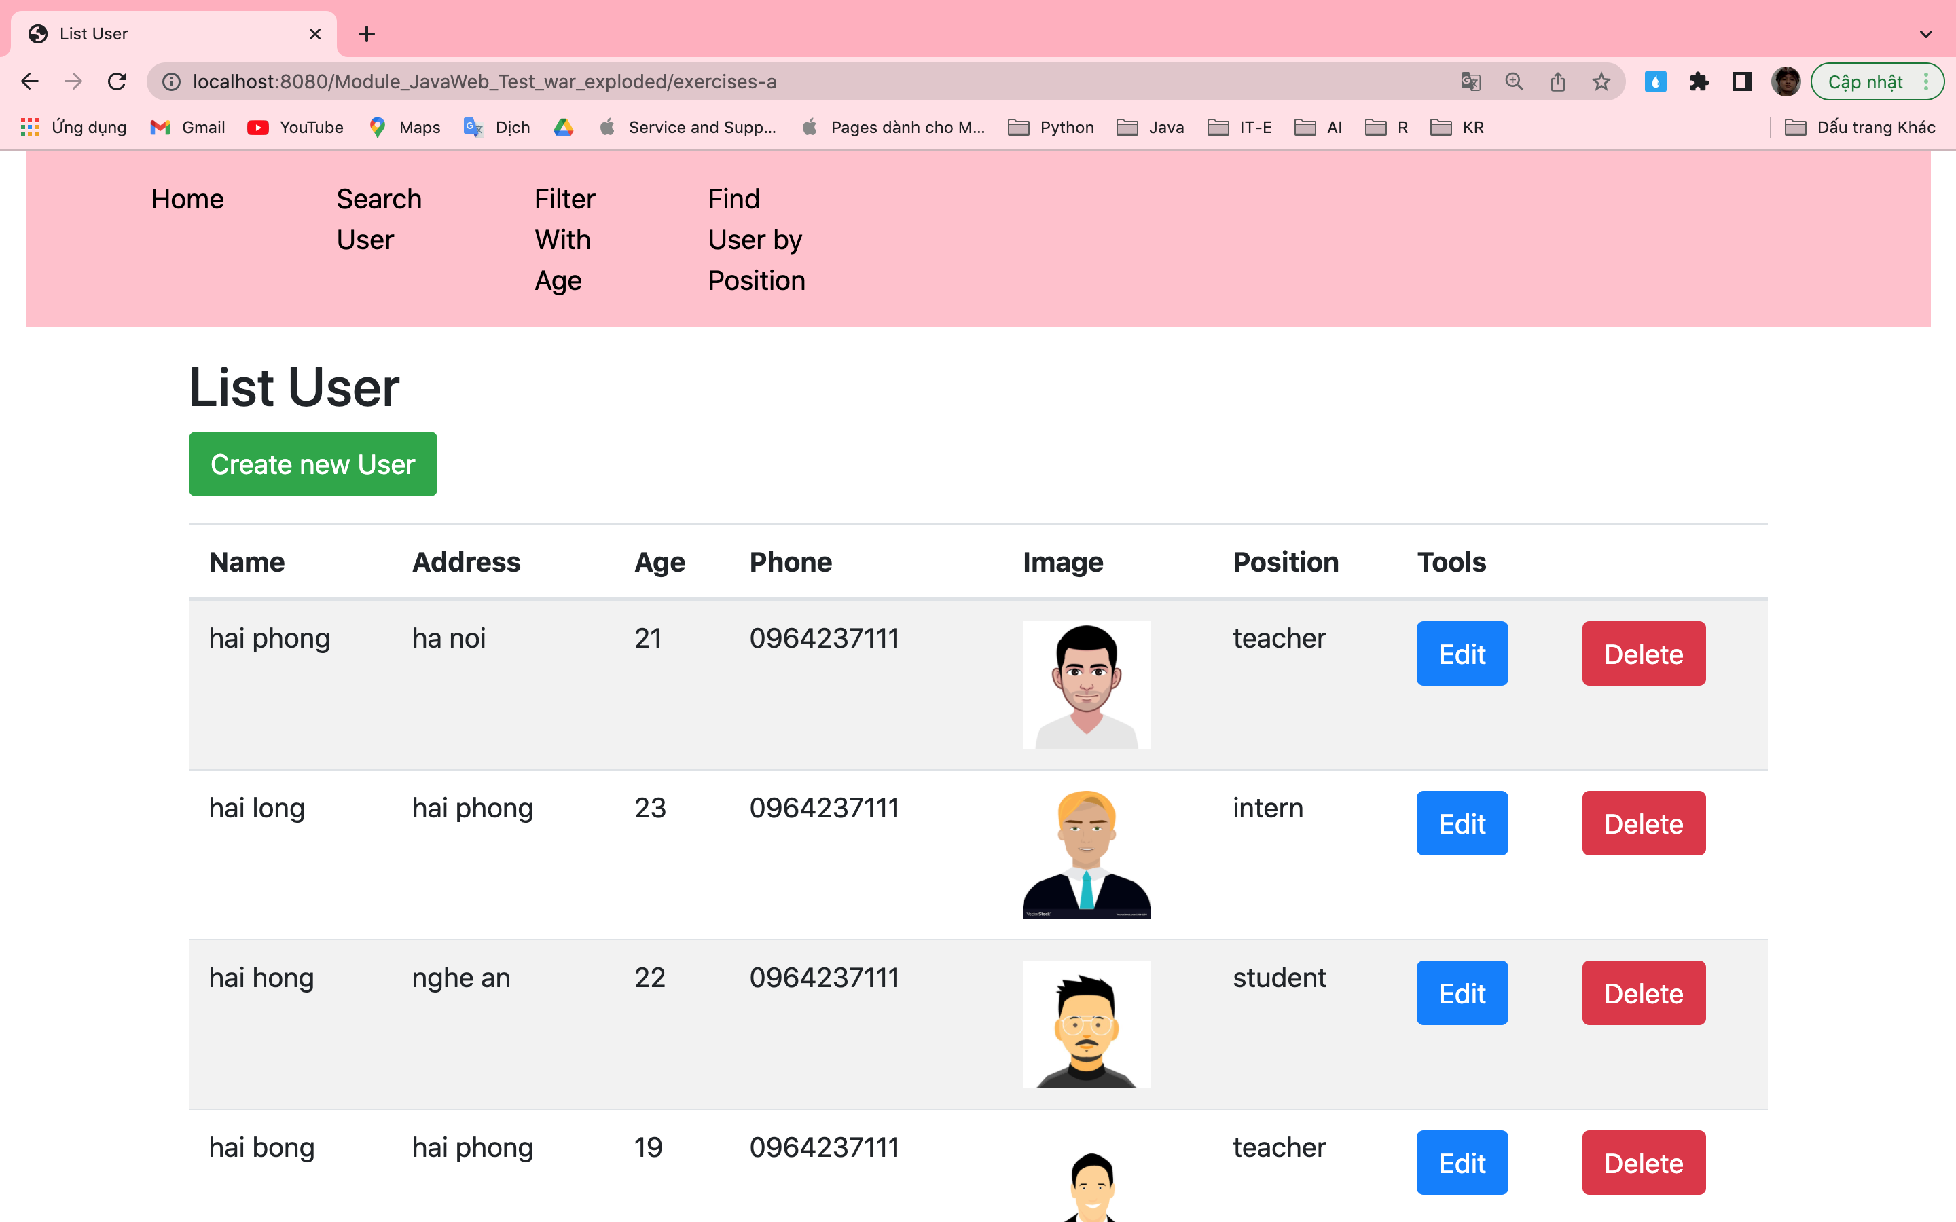

* Add new User

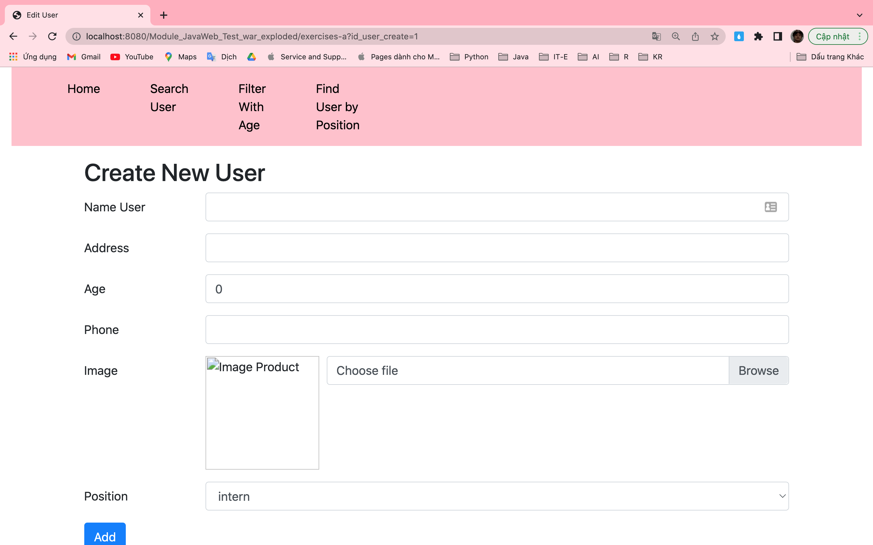

Fill all field input:

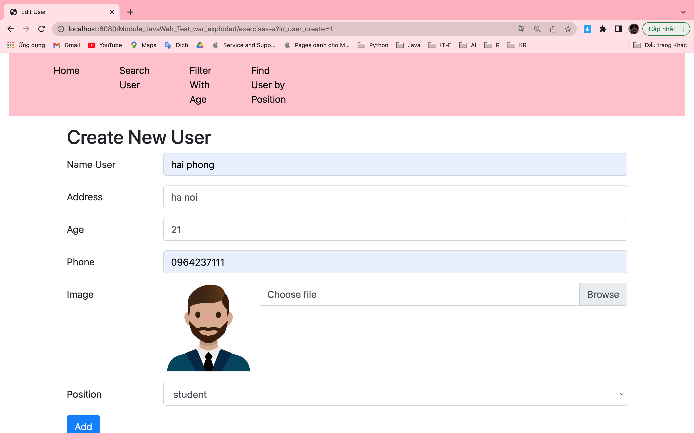

Create new User successful:

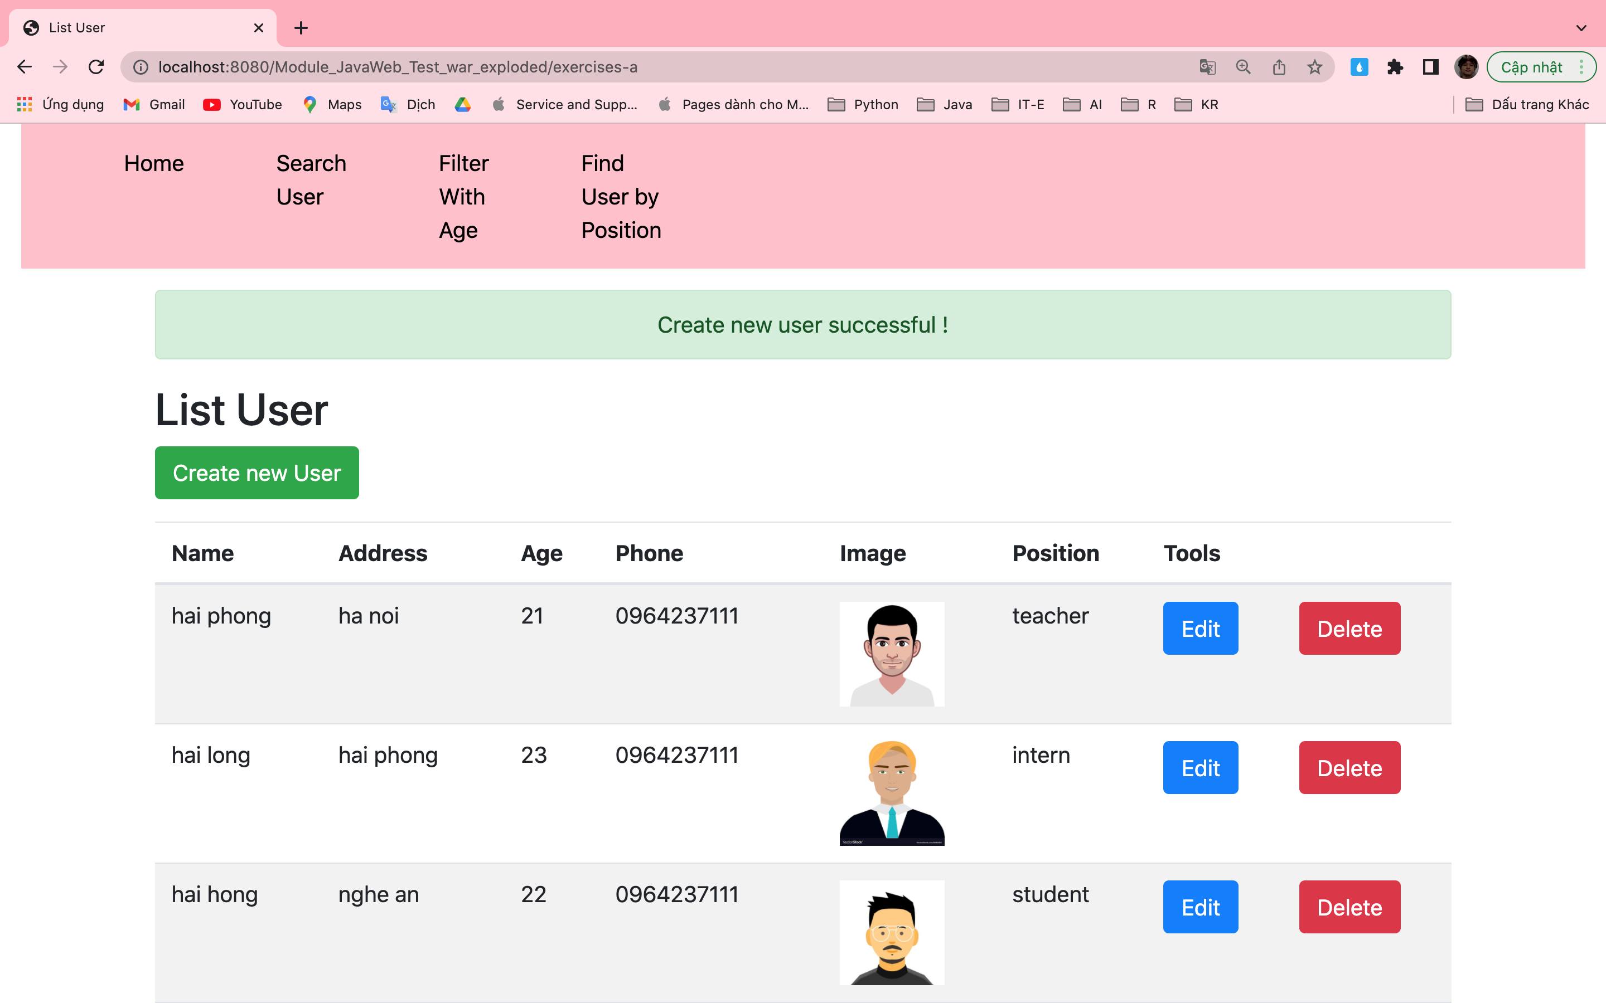

* Edit User: (user id = 1)

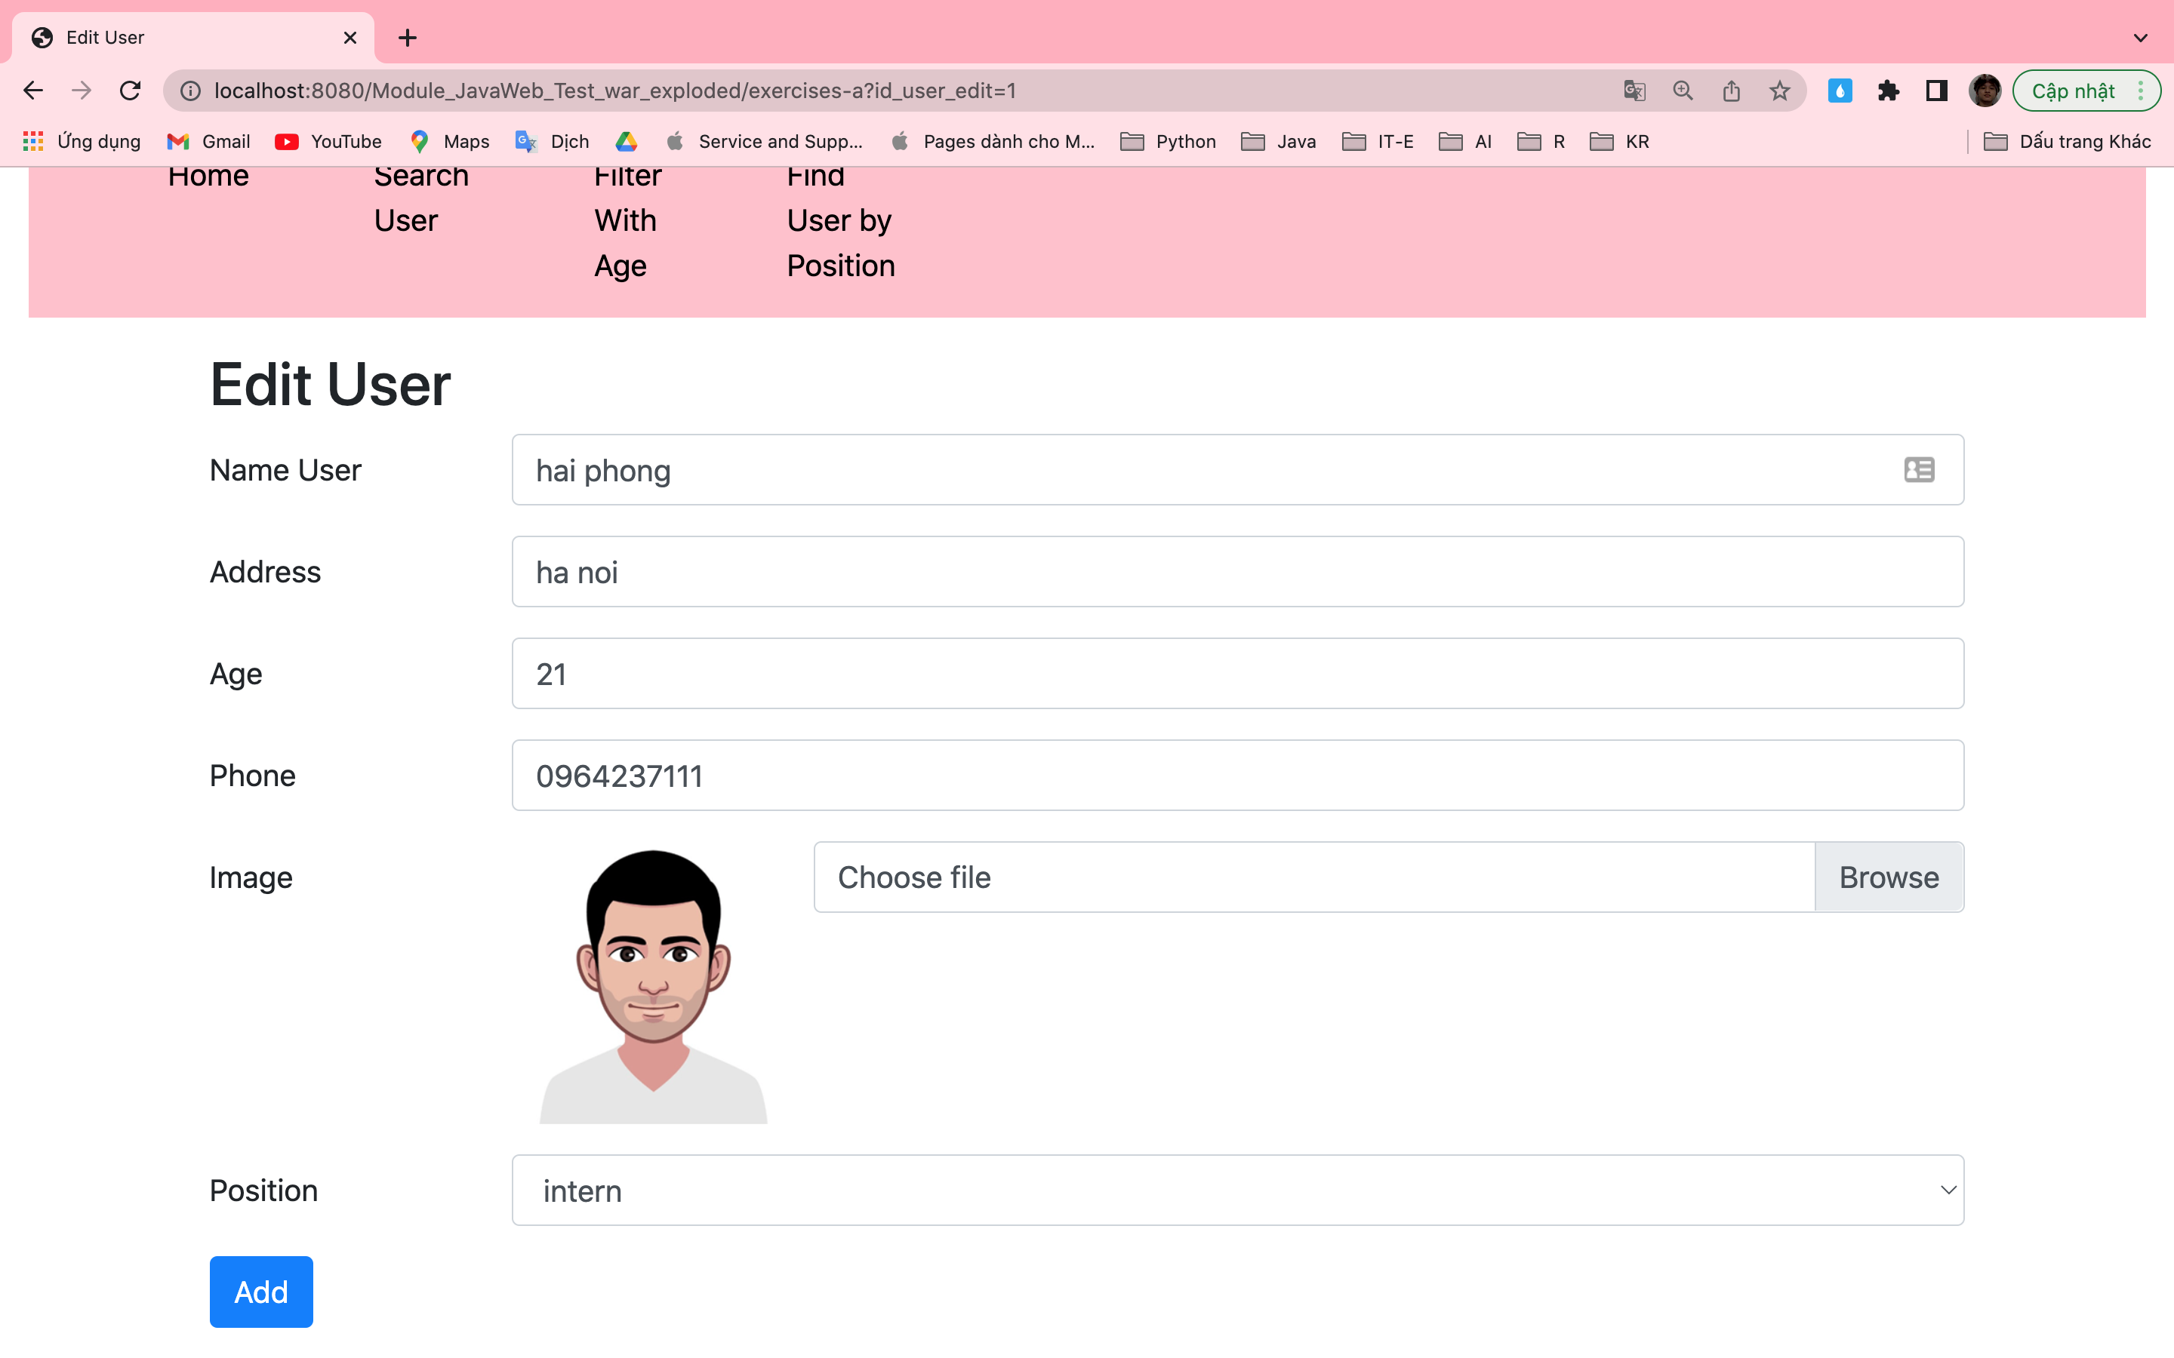

Change all information of user:

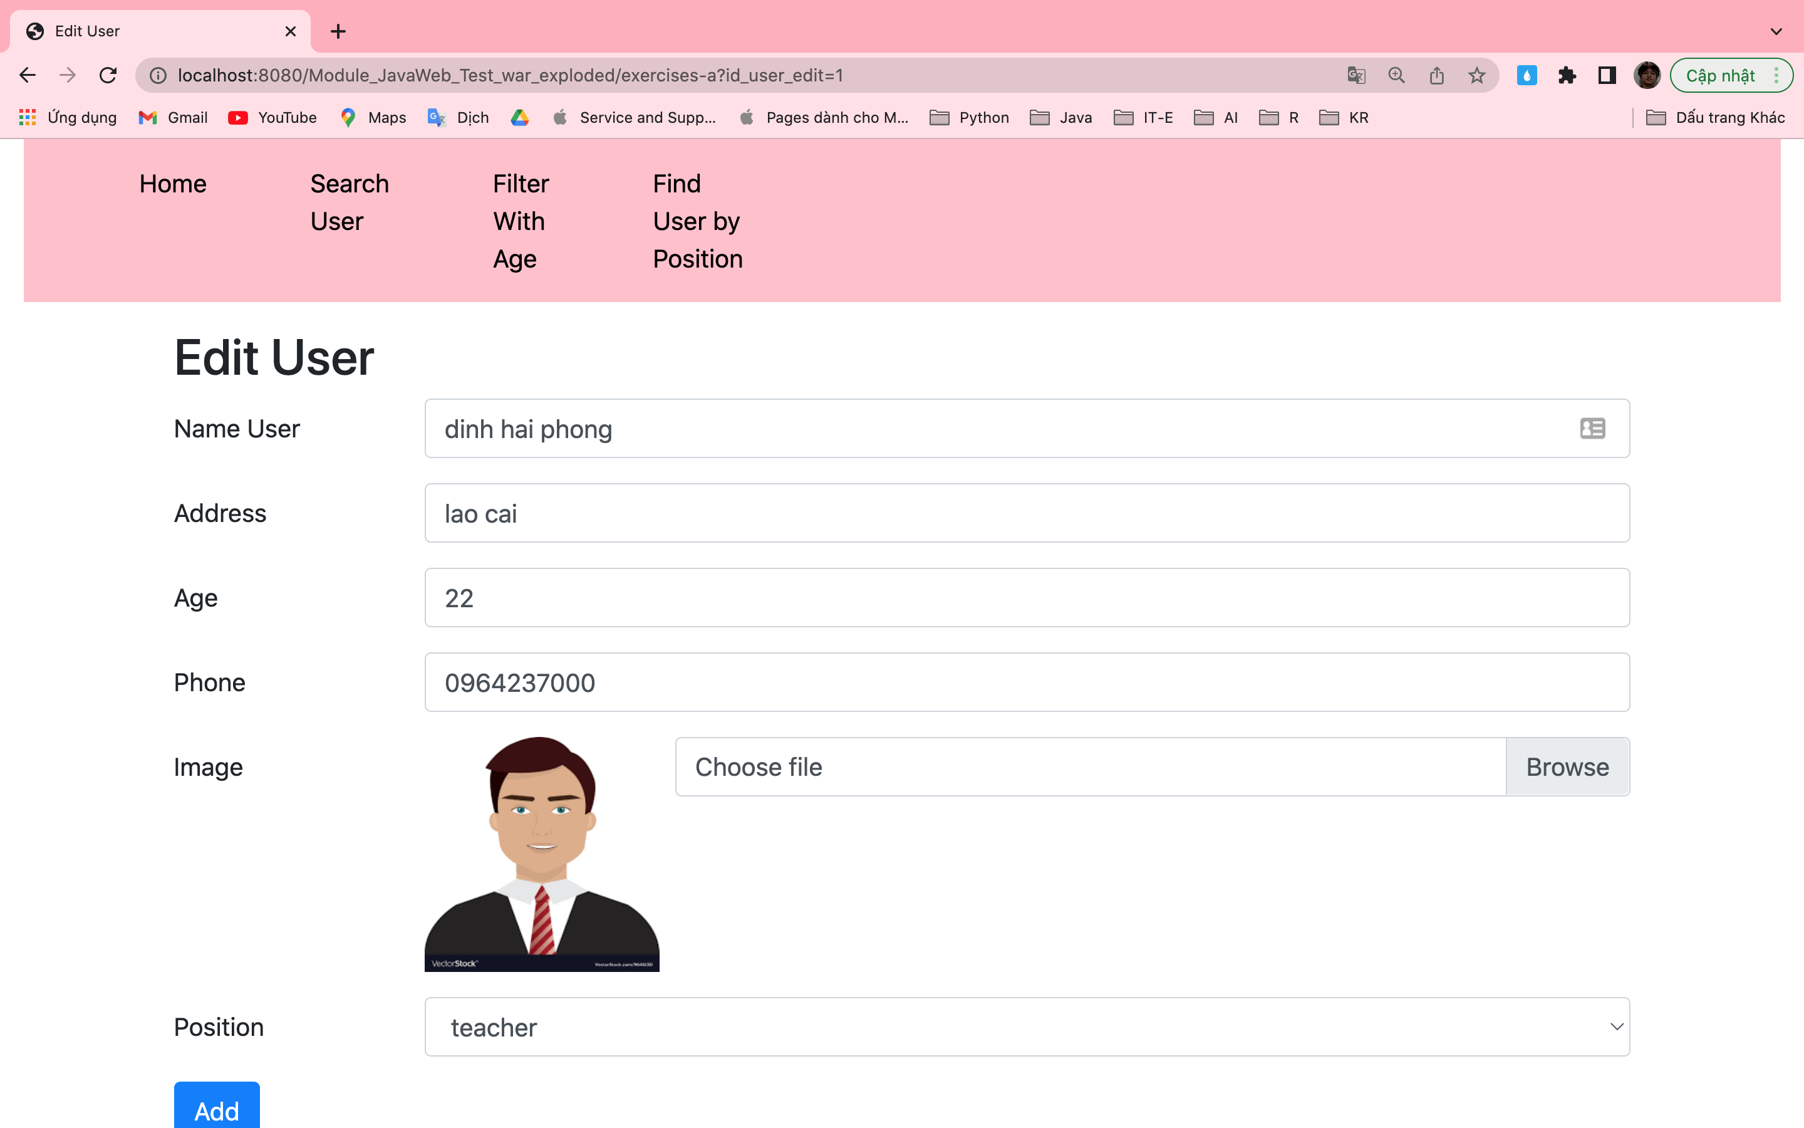

Change user id = 1 successful:

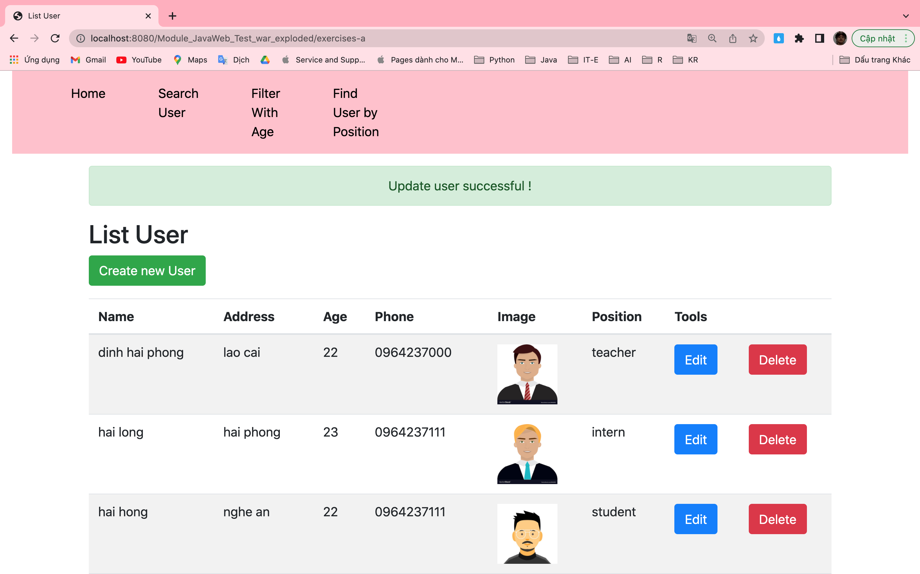

* Delete user id = 1

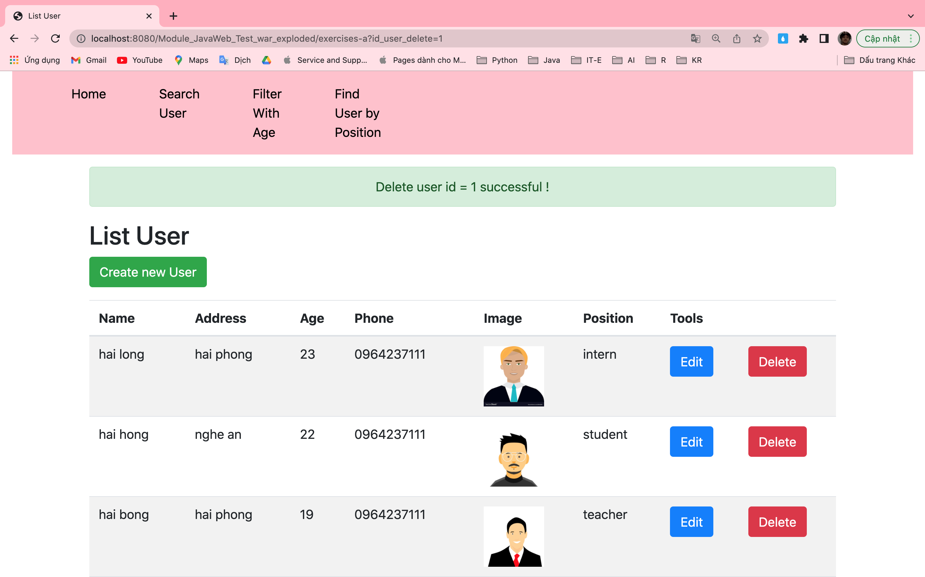

Incomplete:

Wrong vietnamese font:

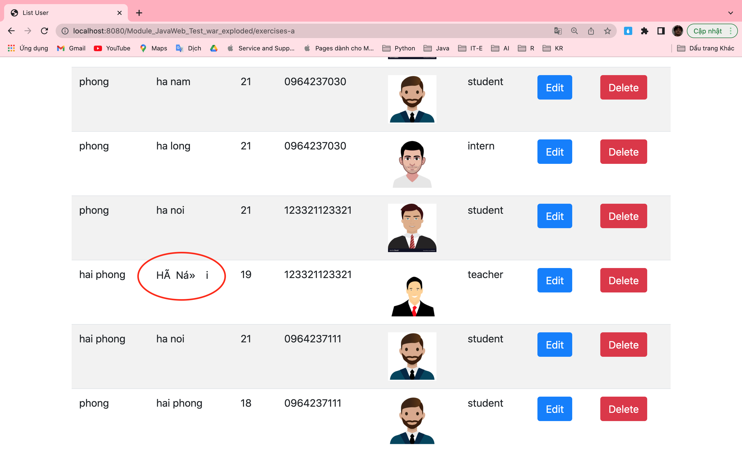

Haven't validated the user's information

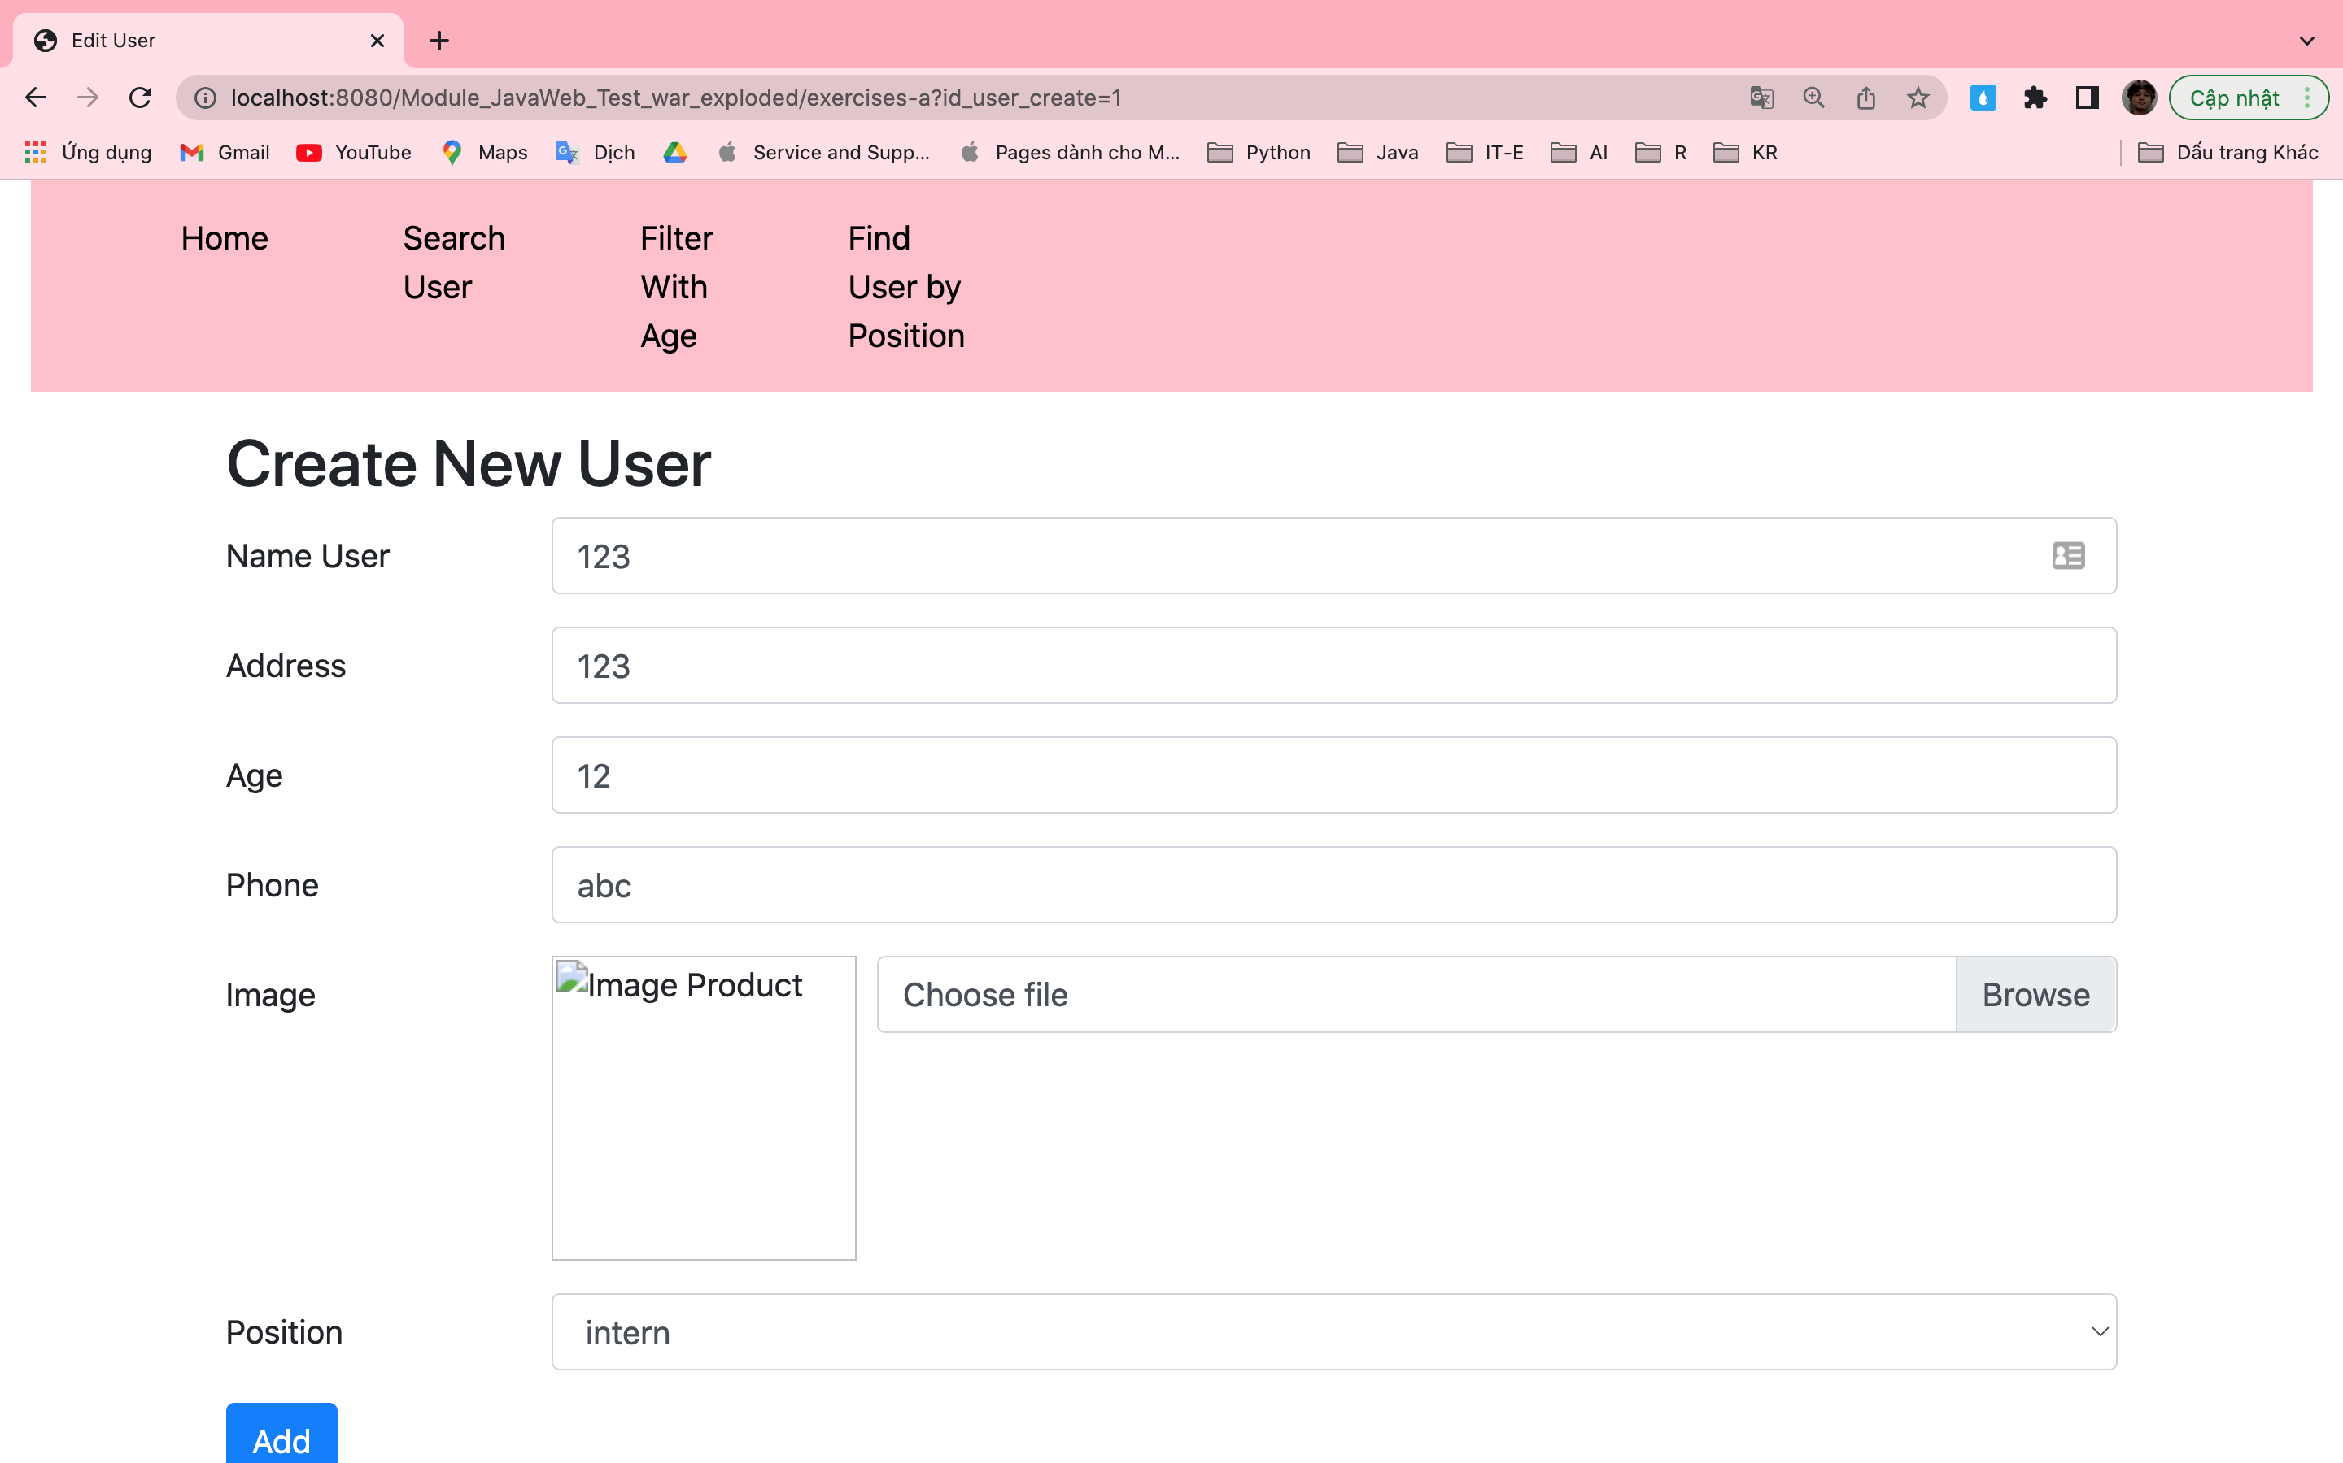

B: Requirements: Write a program to search for users by name field or address field or phone field in table users

Complete:

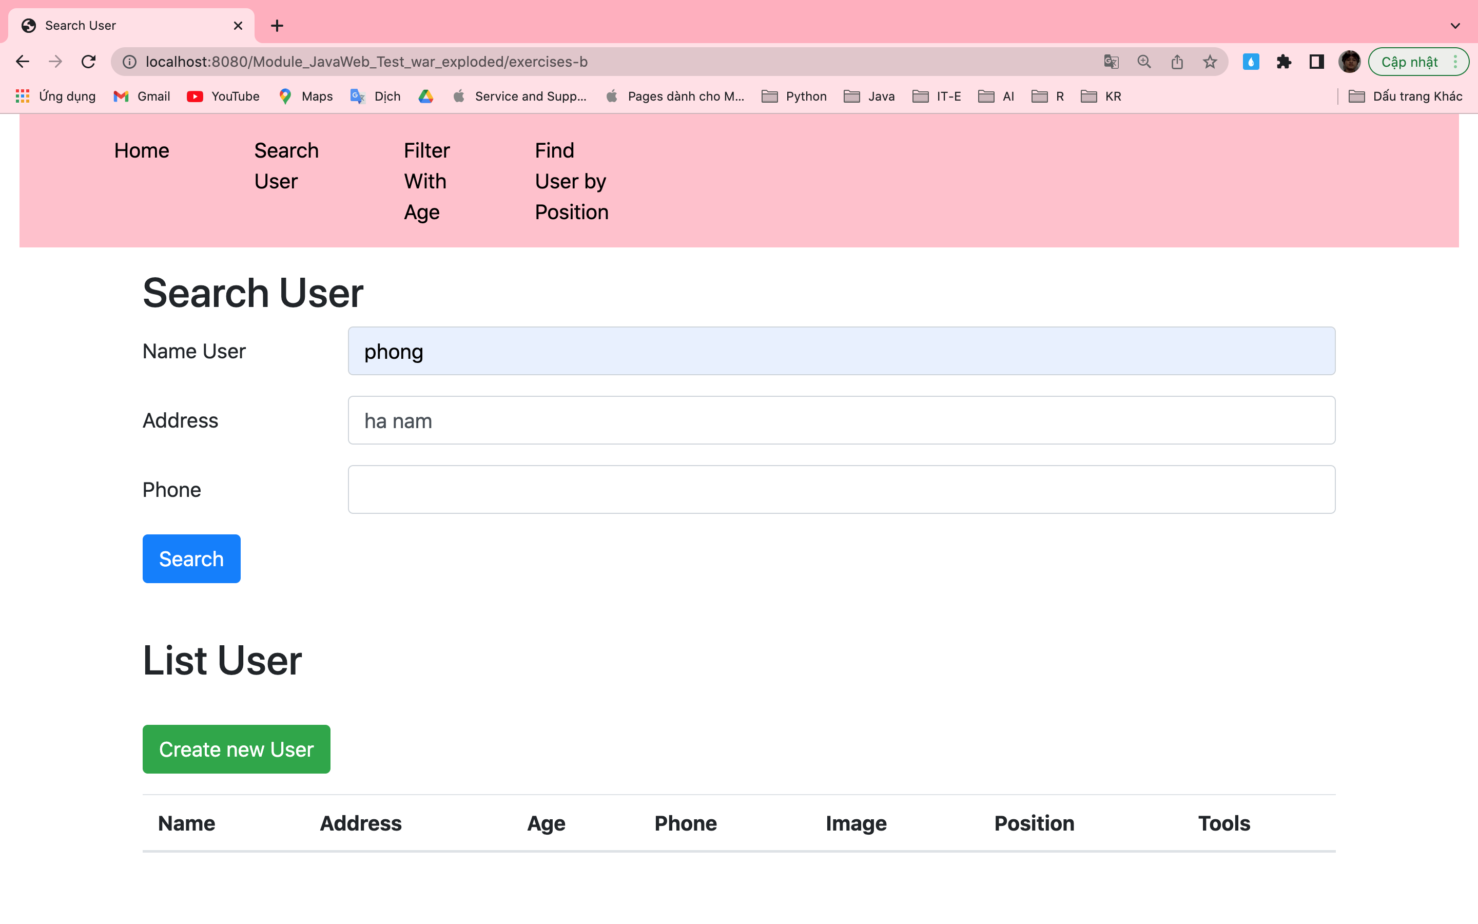

Results returned when searching for name = "phong" and address = "ha nam"

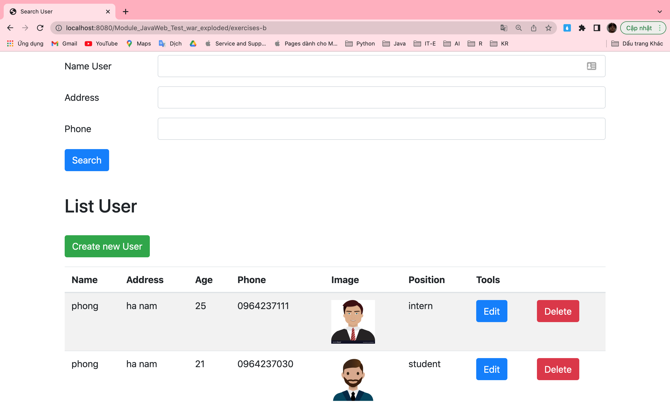

C: Requirements: Write a program that allows filtering users by age range, for example allowing to find users whose age is greater than 10 and less than 20.

Complete:

Example: find whose age is greater than 19 and less than 23:

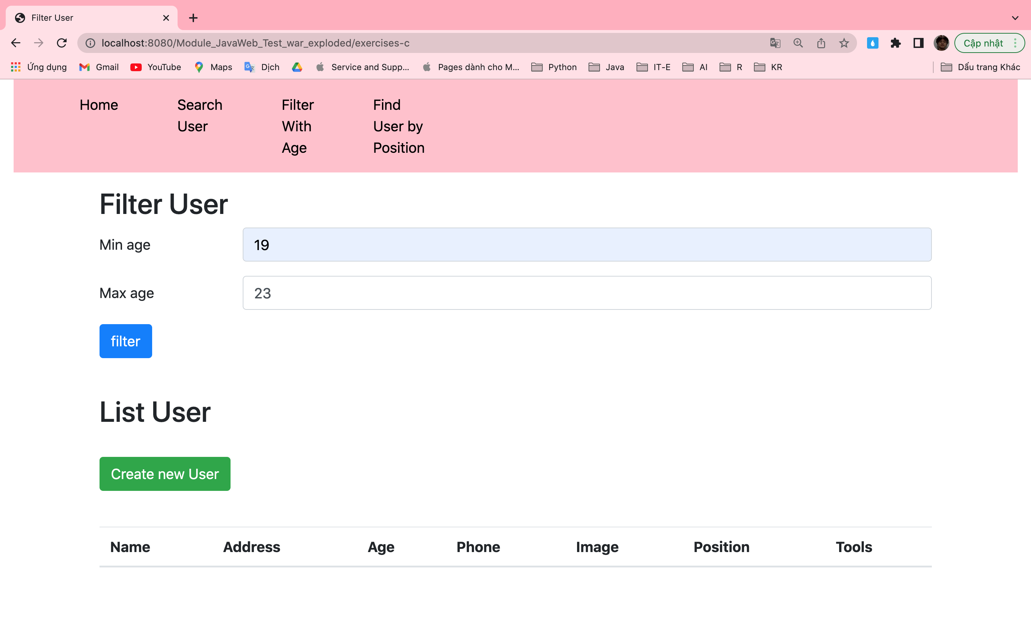

Result:

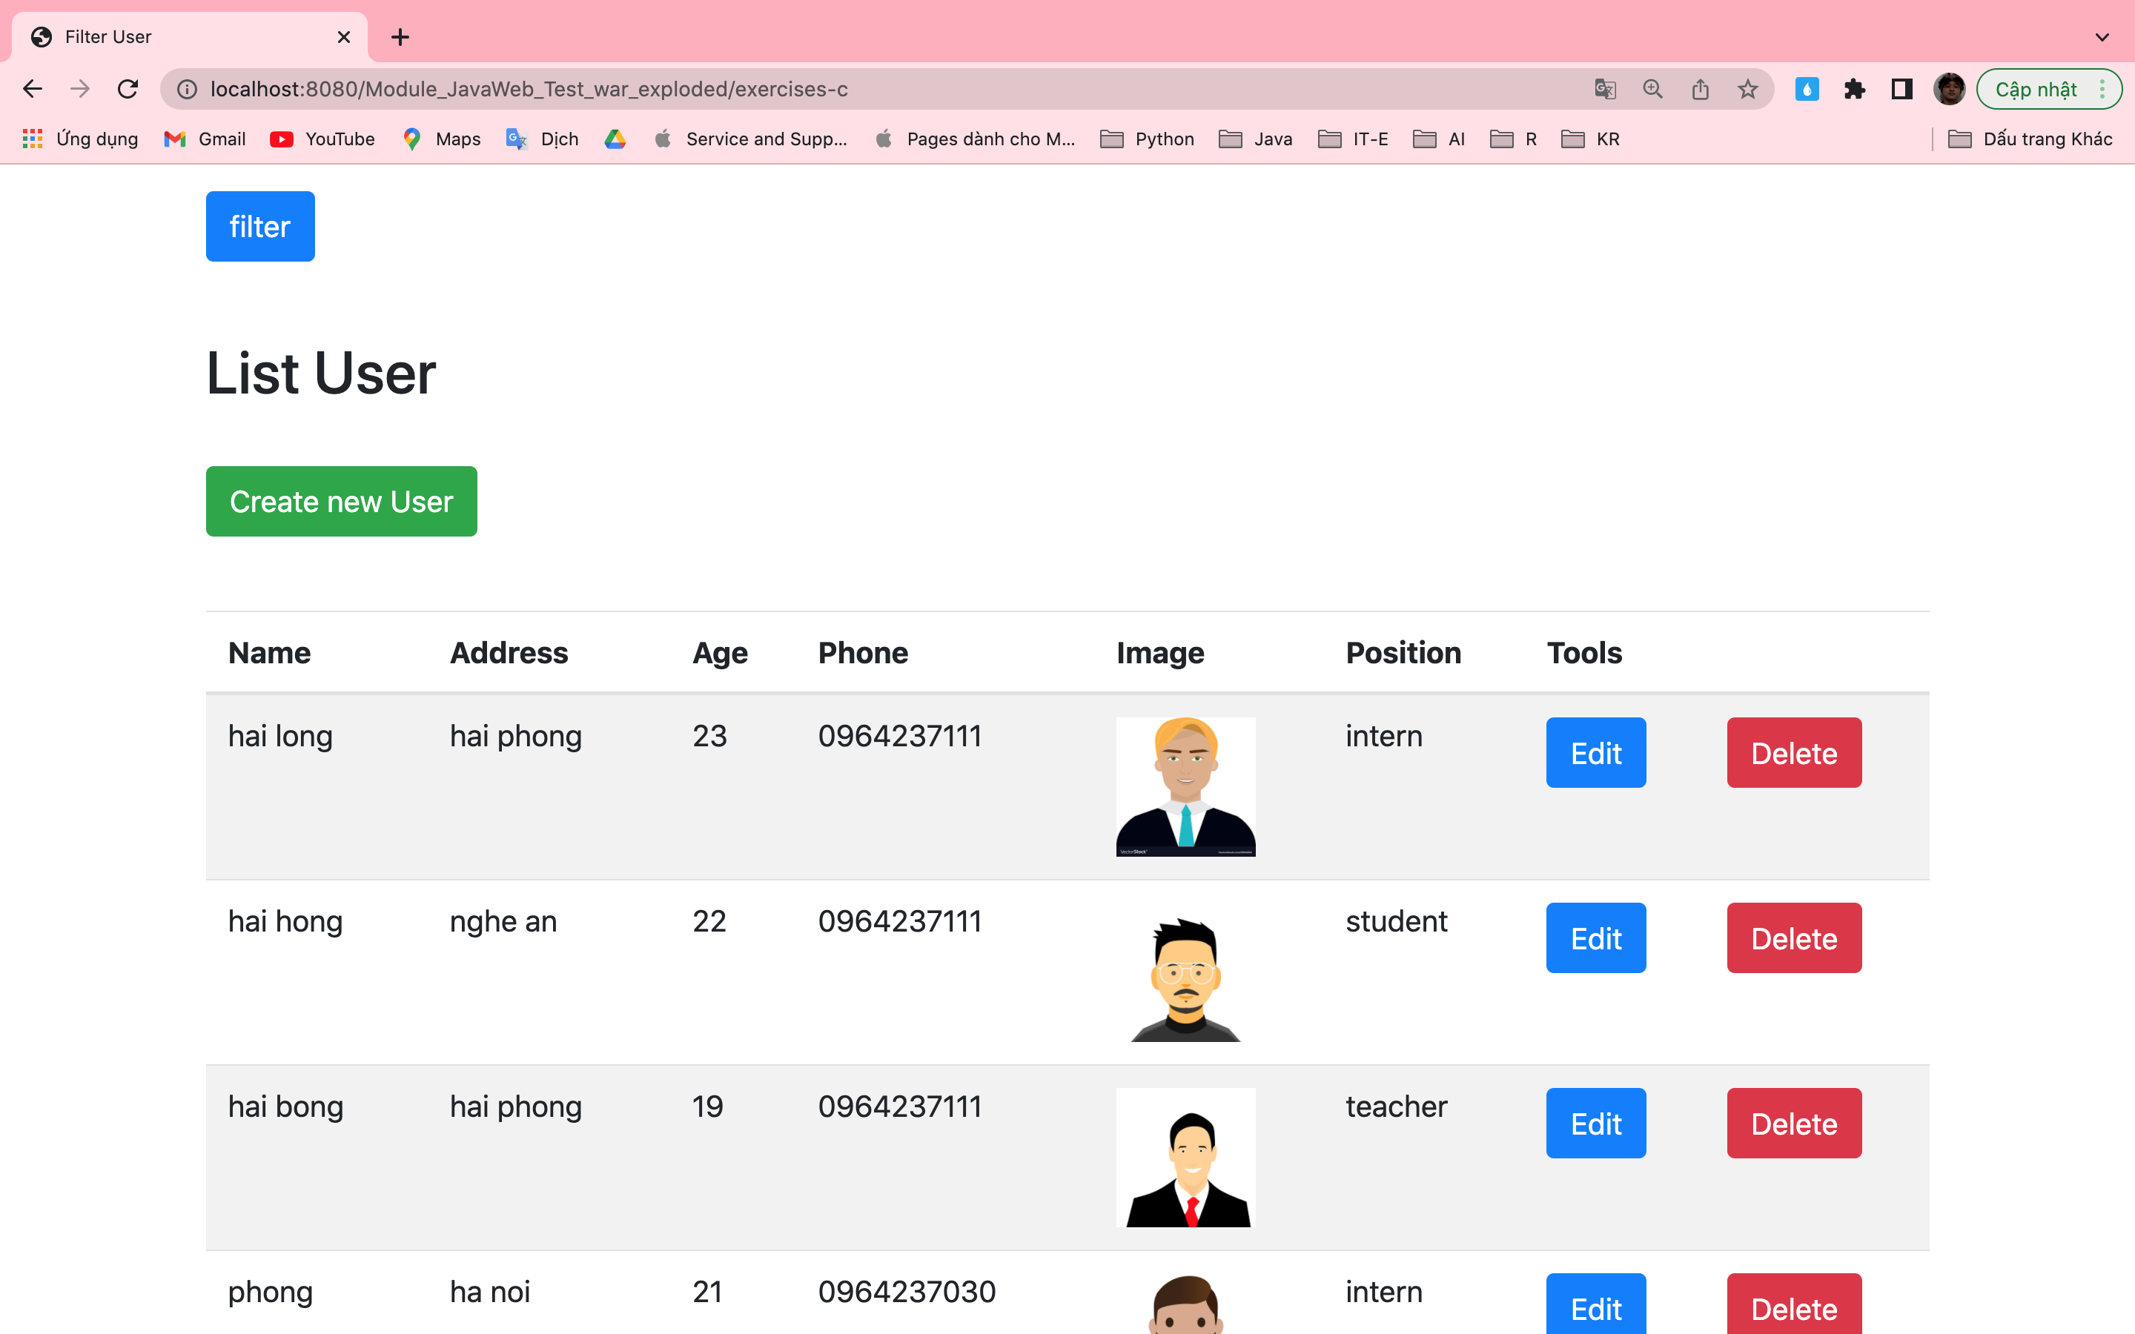

Incomplete:

Haven't validated the user's age min and max

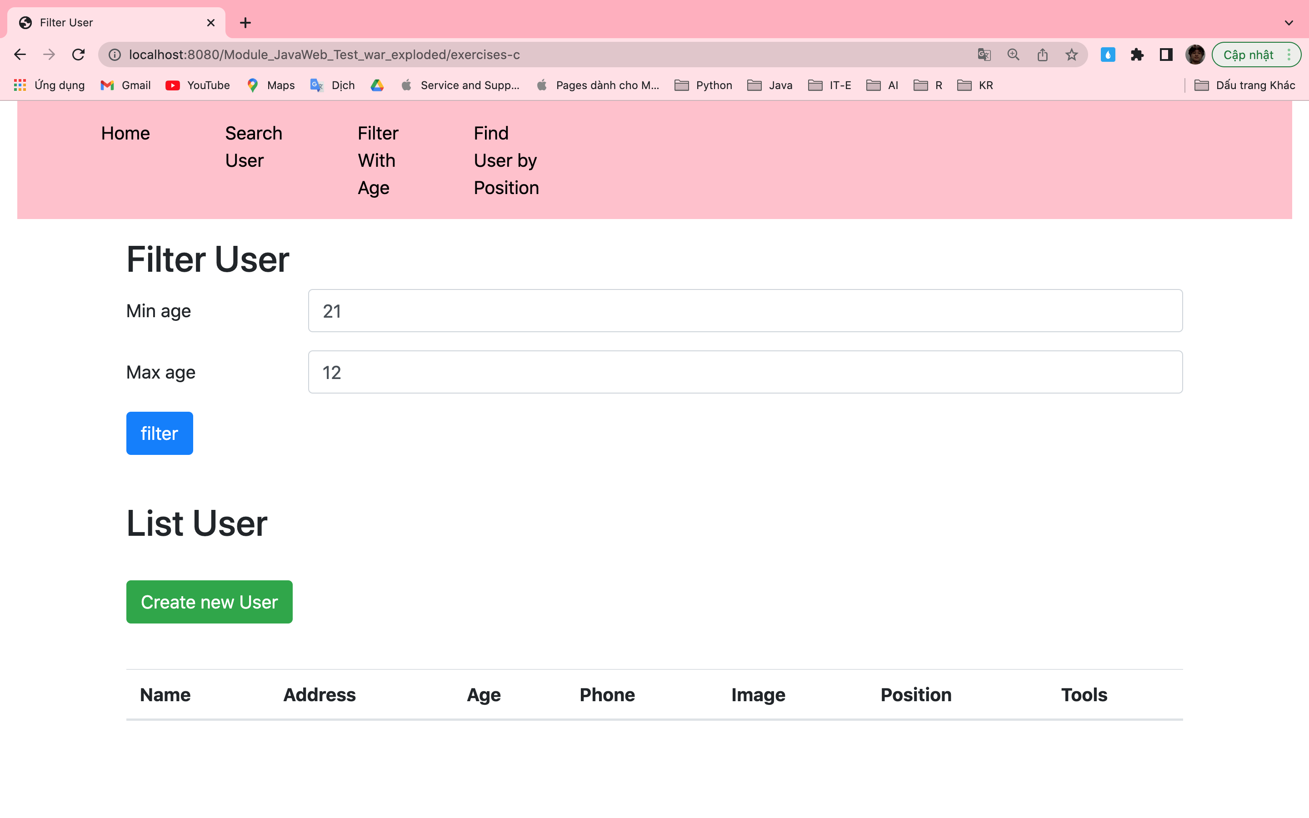

E: Requirments: Create a statistical interface by position type.

Complete:

Default:

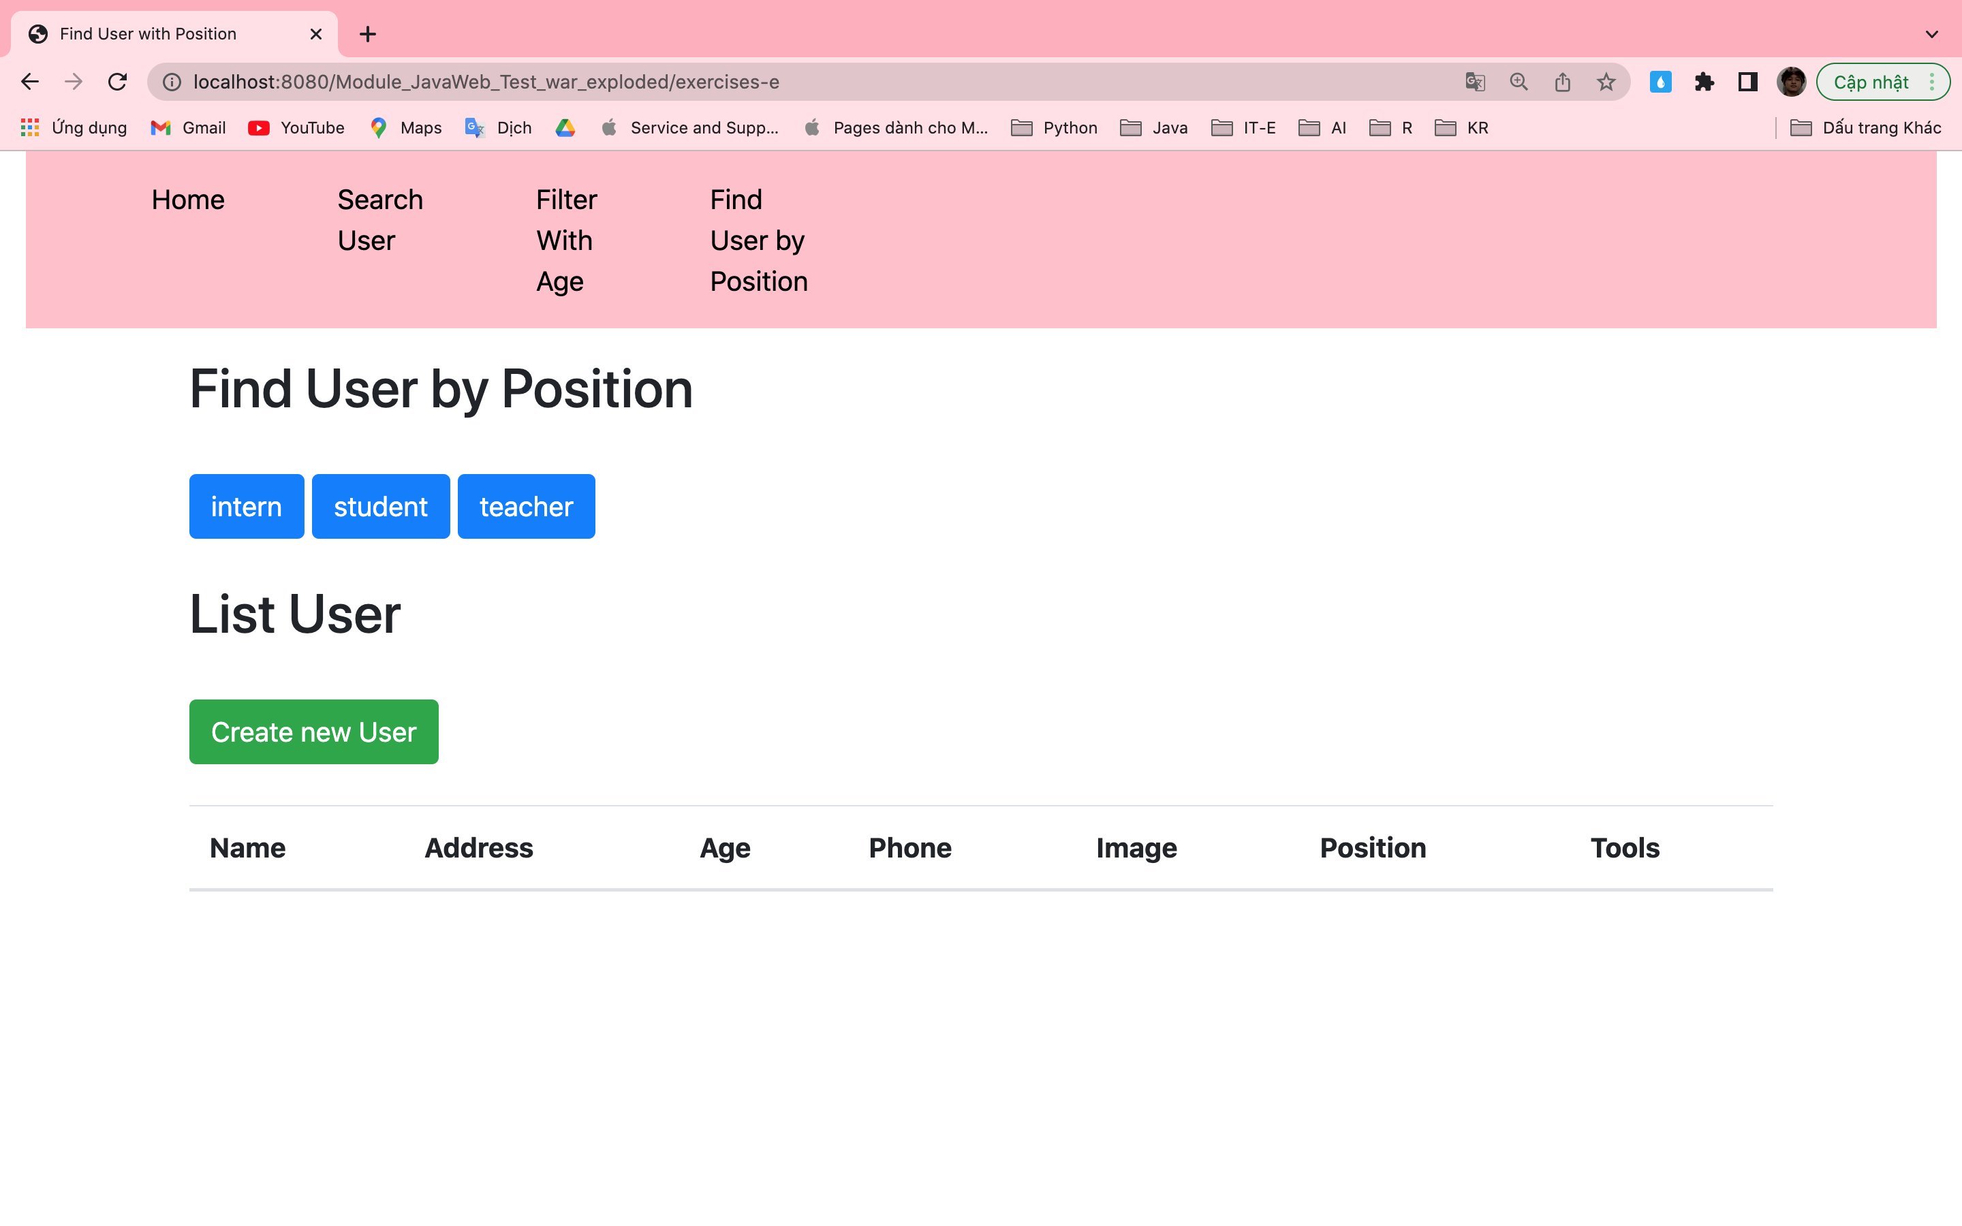

Click on button with name “intern” and this is result:

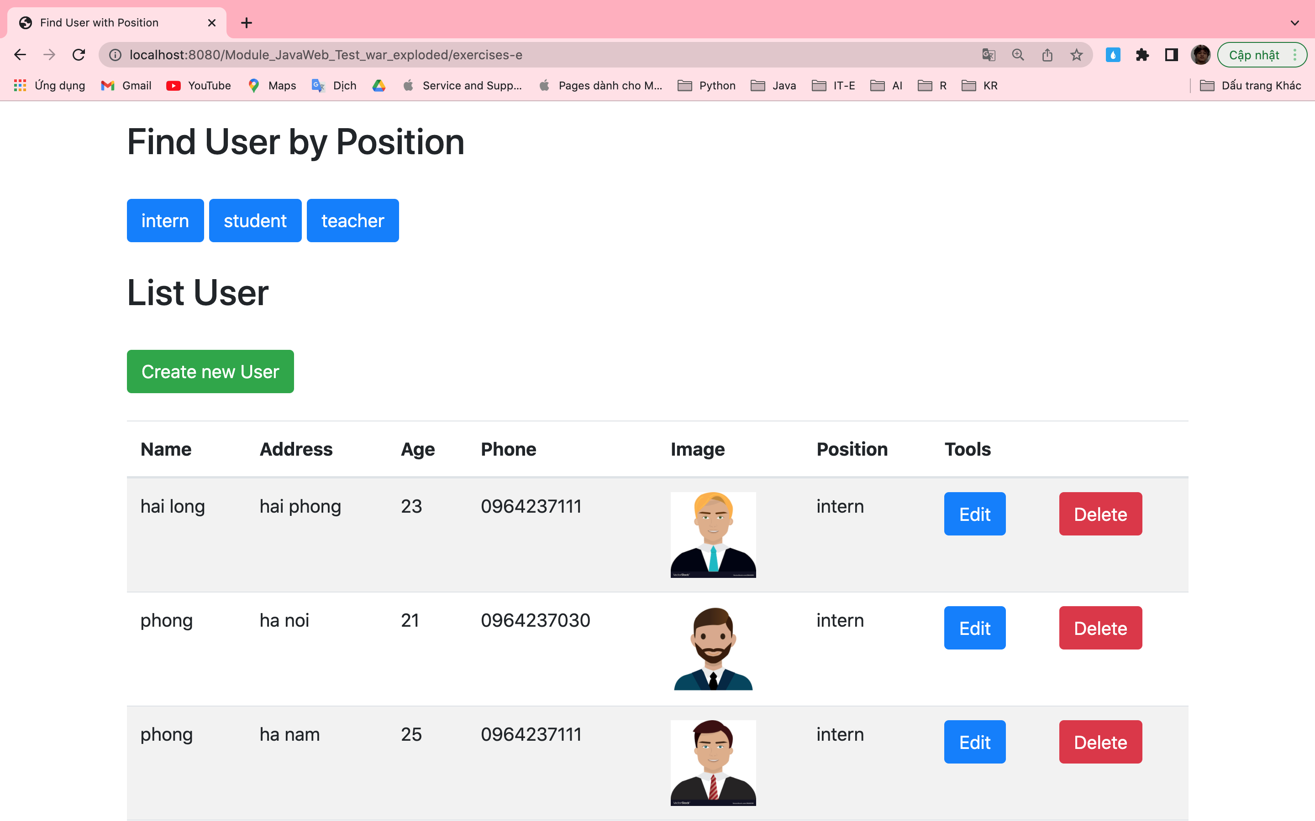

Click on button with name “student” and this is result:

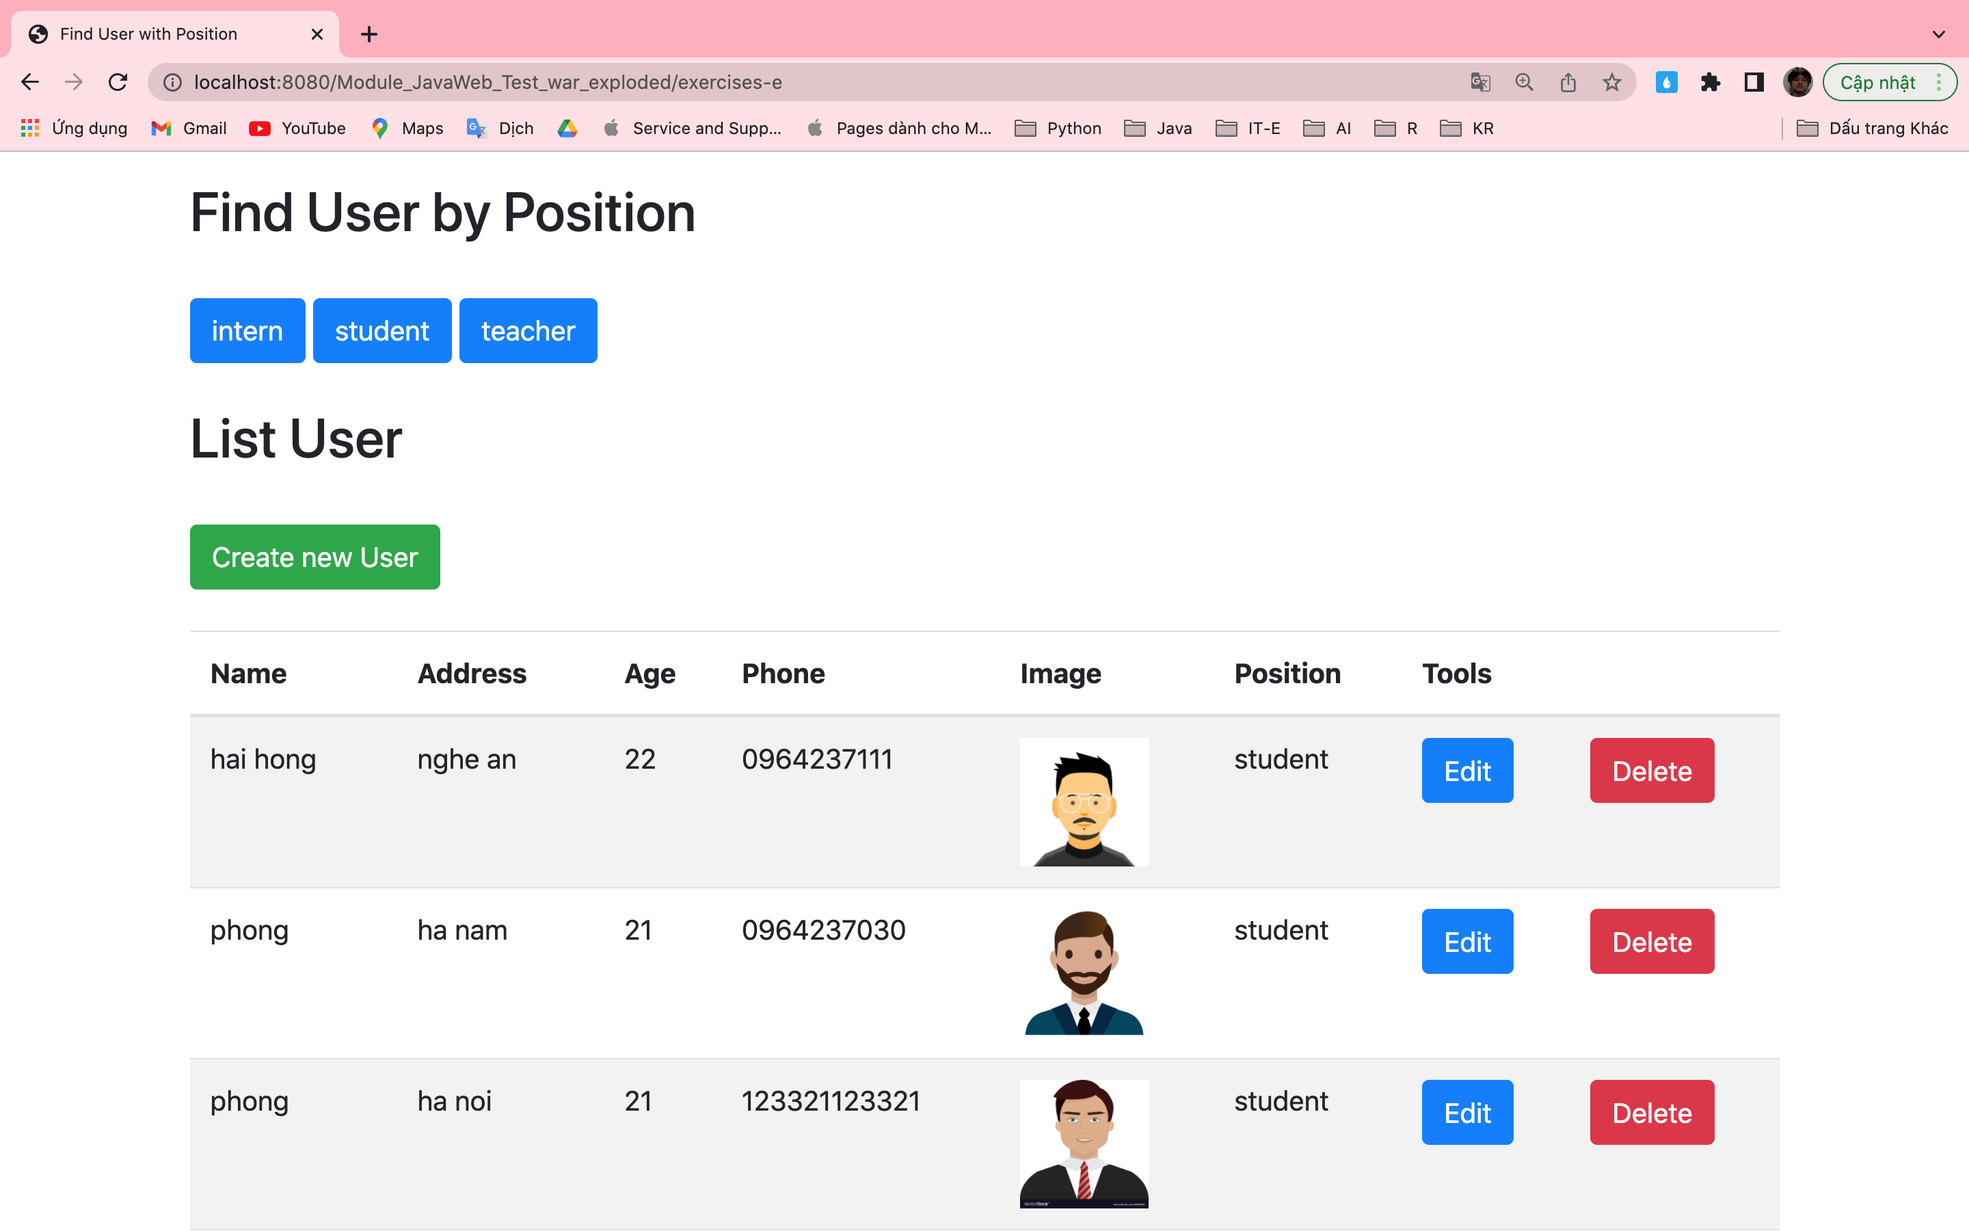

Click on button with name “teacher” and this is result:

